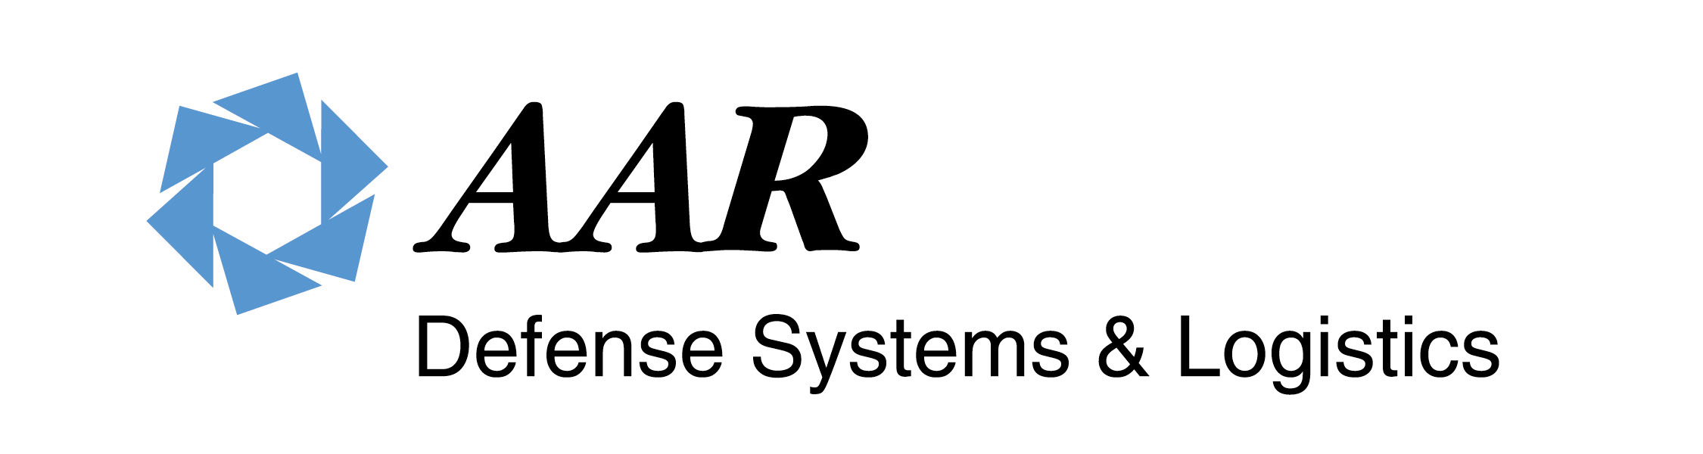
U.S. Supplier
DDTC Registration Certification

AAR Defense Systems & Logistics is a Defense/Military Contractor and Distributor. To comply with U.S. International Traffic in Arms Regulations (ITAR) administered by the U.S. State Department’s Directorate of Defense Trade Controls (DDTC), we respectfully request all U.S. Customers certify their registration with DDTC.

DDTC registration is required by law for U.S. companies dealing in defense equipment per ITAR 122.1; registration requirements:
(a)Any person who engages in the United States in the business of either manufacturing or exporting defense articles or furnishing defense services is required to register with the Directorate of Defense Trade Controls. For the purpose of this subchapter engaging in the business of manufacturing or exporting defense articles or furnishing defense services requires only one occasion of manufacturing or exporting a defense article or furnishing a defense service. Manufacturers who do not engage in exporting must nevertheless register.
(b) Exemptions. Registration is not required for:
(1) Officers and employees of the United States Government acting in an official capacity.
(2) Persons whose pertinent business activity is confined to the production of unclassified technical data only.
(3) Persons all of whose manufacturing and export activities are licensed under the Atomic Energy Act of 1954, as amended.
(4) Persons who engage only in the fabrication of articles for experimental or scientific purpose, including research and development.
(c) Purpose. Registration is primarily a means to provide the U.S. Government with necessary information on who is involved in certain manufacturing and exporting activities. Registration does not confer any export rights or privileges. It is generally a precondition to the issuance of any license or other approval under this subchapter.

As defined under ITAR 22 CFR 120.6: “Defense article means any item or technical data designated in
§ 121.1 of this subchapter. The policy described in § 120.3 is applicable to designations of additional items. This term includes technical data recorded or stored in any physical form, models, mockups or other items that reveal technical data directly relating to items designated in § 121.1 of this subchapter. It does not include basic marketing information on function or purpose or general system descriptions.”

Please provide the information requested below:

Company Name:
Address:
City: |  | State: |  | Zip Code:
Contact Name: |  | Title: |  |  | Tele#.

Are you registered with Directorate of Defense Trade Controls? Yes No
IF YES, PLEASE PROVIDE EXPIRATION DATE:

Are you exempt from registration requirements under ITAR 122.1(b) above? Yes No
IF YES, PLEASE STATE EXEMPTION:

Note:
No Shipment of ITAR controlled product intended for export can be released to a non-registered company.

Authorized Company Representative Signature below certifies that the above statements are true:

_______________________ ____________________________ ___/___/20
Signature Name & Title

AAR DS & L will keep the completed form in the customer file for Export Compliance verification purposes only.

